

*Operating Lease Support System Phase-2 Project*

*for*



***Functional Specification FC.AD.2.2***

***Monitor Regular Maintenance Schedule of OPL Unit***

Revision 1.0

**PT. Berlian Sistem Informasi**

KTB Annex Bld. 4th Floor, Jl. Jend. A. Yani. Pulomas,

Tel. +62 21 4786 7575 (Hunting) Fax. +62 21 4714964 www.bsi.co.id

Document Control

|  |  |
| --- | --- |
| **Author** | Dimas Oktarianto |
| **File Name** |  |
| **Path** | \OPRLEASE-P2\Deliverable Based-2\Working\04.Design\04.02 Functional Spesification\ |
| **Number of Pages** |  |

Revision History

|  |  |  |  |
| --- | --- | --- | --- |
| **Date** | **Revision** | **Description** | **Author** |
| 10/11/2015 | 0.0 | Initial Creation | Dimas Oktarianto |
| 17/12/2015 | 0.1 | QCO Review :   * Add some words to sentence (Page 10). * Revise few component and name on Screen Functionality (Page 17). * Revise Source Data Structure into Tb_OPL_Branch.BranchShortName and length on agreement number (Page 26). * Revise Data type on maintenance budget into decimal (page 27) | Dimas Oktarianto |
| 04/01/2016 | 0.2 | QCO Review :   * Revise Distribution List and Document Approval | Dimas Oktarianto |
| 12/01/2016 | 1.0 | 1st Baseline | Dimas Oktarianto |

Distribution List

|  |  |  |
| --- | --- | --- |
| Name | Organization | Roles |
| Mr. Yutaro Sanada | Dipo Star Finance, PT | DSF Project Director |
| Mr. Shinji Hosokawa | Dipo Star Finance, PT | DSF Project Advisor |
| Mr. Ahmad Fikri | Dipo Star Finance, PT | DSF Project Advisor |
| Mr. Abdul Somad | Dipo Star Finance, PT | DSF Project Manager |
| Mr. Delta Riangga | Dipo Star Finance, PT | DSF Key User |
| Mr. Mochamad Idris | Dipo Star Finance, PT | DSF Key User |
| Mrs. Herni Hembang | Dipo Star Finance, PT | DSF Key User |
| Mr. Junaidi Didy | Dipo Star Finance, PT | DSF Key User |
| Mr. Dedi Supriyadi | Dipo Star Finance,PT | DSF Key User |
| Mrs. Elke Hilviana | Dipo Star Finance,PT | DSF Key User |
| Mr. Mukhlis Ibrahim | Dipo Star Finance, PT | DSF IT Department Representative |
| Mr. Roby Wijaya | Dipo Star Finance, PT | DSF IT Department Representative |
| Mr. Daiki Kamada | Berlian Sistem Informasi, PT | BSI Project Director |
| Mr. Feri Irawan | Berlian Sistem Informasi, PT | BSI Project Advisor |
| Mr. Grand Zah Putra | Berlian Sistem Informasi, PT | BSI Project Manager |
| Mr. Dimas Oktarianto | Berlian Sistem Informasi, PT | BSI Business Analyst |

Document Approval

By signing this document I acknowledge I have read the document and give the Project Management Team approval to proceed.

|  |  |  |  |
| --- | --- | --- | --- |
| Role | Name | Signature | Date |
| DSF Project Director | Mr. Yutaro Sanada |  |  |
| DSF Project Director | Mr. Shinji Hosokawa |  |  |
| DSF IT Advisor | Mr. Shinya Tsukamoto |  |  |
| DSF IT Advisor | Mr. Ahmad Fikri |  |  |
| DSF PMO | Mr. Roby Wijaya |  |  |
| DSF DSF Biz. Operation Leader | Mr. Abdul Somad |  |  |
| DSF IT Operation Leader | Mr. Mukhlis Ibrahim |  |  |
| BSI Project Director | Mr. Daiki Kamada |  |  |
| BSI Project Manager | Mr. Grand Zah Putra |  |  |
| BSI Technical Leader | Mr. Raymond |  |  |
| BSI Business Analyst | Mr. Dimas Oktarianto |  |  |

Table of Contents

Document Control 2

Revision History 2

Distribution List 3

Document Approval 4

1 Introduction 6

1.1 Purpose 6

1.2 Scope 6

1.3 Definitions, Acronyms, and Abbreviations 6

1.4 References 6

2 Configuration 6

3 Specification Detail : AD.2.2 Monitor Regular Maintenance Schedule of OPL Unit 7

3.1 Purpose 7

3.2 Screen of Configuration Access 7

3.3 Screen Functionality 7

3.4 Operation Flow 7

3.5 Screen Detail 11

3.6 Screen Functionality 15

3.7 Operation Description 19

3.8 Data Structure 27

3.9 Screen Item List 29

3.10 Entity Relationship Diagram 30

1. Introduction
   1. Purpose

Functional Specification is a document to describe the detail of functions system which includes screen design and logic formula. This document will be used for system development.

* 1. Scope

Functional Specification Document contains screen design, screen functionality, process flow, and data structure of AD.2.2 Monitor Regular Maintenance Schedule of OPL Unit.

Here are the scope for AD.2.2 Monitor Regular Maintenance Schedule of OPL Unit :

1. **AD.2.2.1 View List of Maintenance Agreement**

To view List Maintenance of Unit based on Agreement, Purchase Order, and Unit Management.

1. **AD.2.2.8 Update Schedule**

Update Schedule Maintenance of Unit.

1. **AD.2.2.18 Submit Historical Maintenance**

To submit Data Histoical Maintenance.

Output from this function is :

1. RPT.AD.2.2. Report Monthly Maintenance Unit
   1. Definitions, Acronyms, and Abbreviations

List of definitions that are used in this document :

1. WO = Work Order.
2. MU = Maintenance Unit.
3. OPL = Operating Lease.
4. BAST = Berita Acara Serah Terima / Handover Report.
   1. References

This functional specification document refers to **“To Be Design” BSI Unit/ Vehicle Maintenance Process**, module:

1. AD.2.2 Monitor Regular Maintenance Schedule of OPL Unit.
2. Configuration

N/A

1. Specification Detail : AD.2.2 Monitor Regular Maintenance Schedule of OPL Unit
   1. Purpose

Screen of Monitor Regular Maintenance Schedule of OPL Unit will be used by PIC Maintenance to monitor and update schedule maintenance of unit. This Screen Function consist of view list of maintenance agreement, update schedule, and Submit Historical Maintenance.

This function covered by **“Monitor Regular Maintenance Schedule of OPL Unit”** screen.

* 1. Screen of Configuration Access

Here are the access rights for **“Monitoring Regular Maintenance Schedule”** screen users:

|  |  |  |  |  |
| --- | --- | --- | --- | --- |
| ***User*** | ***Create*** | ***Read*** | ***Update*** | **Authorization** |
| PIC Maintenance | - | V | V | V |
| Admin | - | V | - | V |

Legend: V = Have the Access

Note:

1. Read: related to read display list of maintenance agreement.
2. Update: related to update schedule maintenance of unit
3. Authorization. Related to Access Screen.
   1. Screen Functionality
4. Display List of Maintenance Agreement.
5. Update Schedule Regular Maintenance for OPL Unit.
6. Submit data historical maintenance.
   1. Operation Flow

Below is Operation flow for Monitoring and print unit preparation process referring to **To Be Design Document Unit/ Vehicle Maintenance**, AD.2.2. Monitor Regular Maintenance Schedule of OPL Unit:

|  |  |
| --- | --- |
| **PIC PC** | **Process** |
|  | AllList.png  Agreement  (OPL Agreement)  Billing Collection  (TB_Billing)  Unit Management  (TB_MGT)  Service History Inquire  (OPLServiceHistory)  Note:  Source  Output & Input |

Below is operation flow of ‘Monitoring Regular Maintenance Schedule of OPL Unit’ which is used to monitor schedule maintenance OPL unit 14 day based on calendar date before due date by PIC Maintenance. In this process pic maintenance confirm maintenance date to workshop and also customer, and create work order:

|  |  |
| --- | --- |
| **PIC PC** | **Process** |
|  | AllList.png  Note:  Source  Output & Input    Unit Maintenance  (TB_MTN_Monitoringschdl)  Agreement  (OPL Agreement)    Billing Collection  (TB_Billing)  Unit Management  (TB_MGT)  Service History Inquiry  (OPLServiceHistory) |

Below is operation flow of ‘Monitoring Regular Maintenance Schedule of OPL Unit’ which is used to monitor and update schedule maintenance OPL unit 1 day before due date by PIC Maintenance. In this process pic maintenance reconfirm to customer:

|  |  |
| --- | --- |
| **PIC PC** | **Process** |
|  | AllList.png  Note:  Source  Output & Input    Unit Maintenance  (TB_MTN_Monitoringschdl)  Agreement  (OPL Agreement)    Billing Collection  (TB_Billing)  Unit Management  (TB_MGT)  Service History Inquiry  (OPLServiceHistory) |

Below is operation flow of ‘Monitoring Regular Maintenance Schedule of OPL Unit’ which is used to monitor and update schedule maintenance of OPL unit on due date day for maintenance by PIC Maintenance. In this process pic maintenance reconfirm to customer:

|  |  |
| --- | --- |
| **PIC PC** | **Process** |
|  | AllList.png  Note:  Source  Output & Input    Unit Maintenance  (TB_MTN_Monitoringschdl)  Agreement  (OPL Agreement)    Billing Collection  (TB_Billing)  Unit Management  (TB_MGT)  Service History Inquiry  (OPLServiceHistory) |

* 1. Screen Detail
* Screen design of ‘List of Maintenance Agreement’, which will be used as an initial screen for Monitoring regular maintenance 14 day before due date, confirm to customer, confirm to workshop, and also create work order. When PIC Maintenance update schedule, Pop up Will be shown and save the updated schedule.

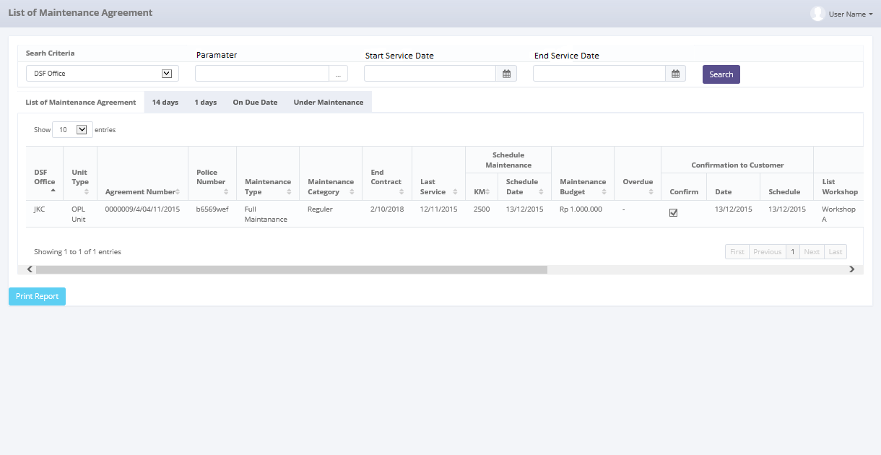

*Screen 1. List of Maintenance Agreement 14 day*

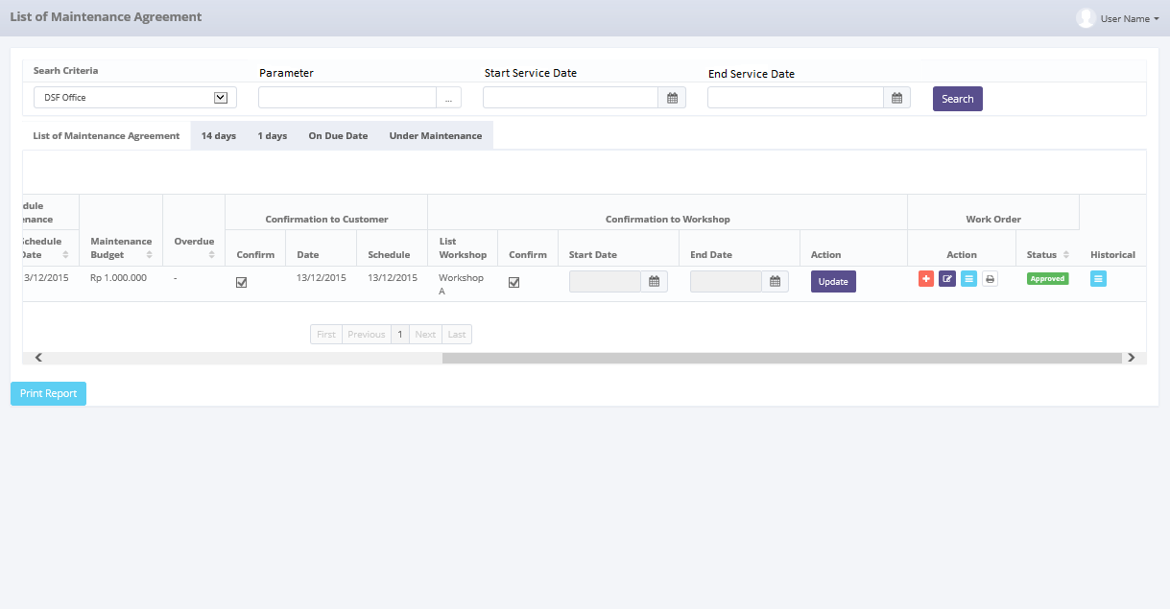

*Screen 2. List of Maintenance Agreement 14 day*

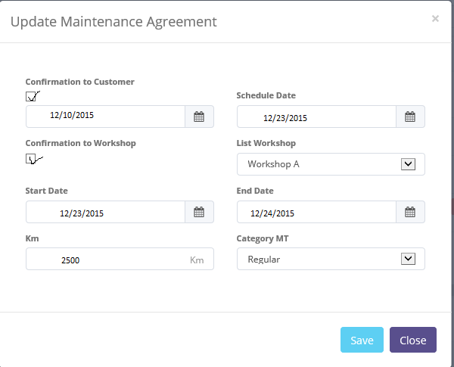

*Screen 3. Pop up Confirmation*

* Screen design of ‘List of Maintenance Agreement’, which will be used as an initial screen for Monitoring regular maintenance 1 day before due date, confirm to customer, and also create work order.



*Screen 4. List of Maintenance Agreement 1 day*



*Screen 5. List of Maintenance Agreement 1 day*



*Screen 6. Pop up Confirmation*

* Screen design of ‘List of Maintenance Agreement’, which will be used as an initial screen for Monitoring regular maintenance on due date, confirm to customer, and also create work order.



*Screen 7. List of Maintenance Agreement on due date*



*Screen 8. List of Maintenance Agreement on due date*



*Screen 9. Pop up Confirmation*

* 1. Screen Functionality

Here are the screen functions from each component in Monitor Regular Maintenance Schedule of OPL Unit screen:

|  |  |  |  |
| --- | --- | --- | --- |
| ***No*** | ***Component*** | ***Name*** | ***Function*** |
| **Header** | | | |
| 1. | Label | List of Maintenance Agreement | List of Maintenance Agreement title |
| **Search Criteria** | | | |
| 2. | Drop down box | Search Criteria | To Select Category for searching maintenance data |
| 3. | Text Field | Parameter | To input parameter for searching maintenance data |
| 4. | Date Picker | Start Service Date | To input start Service Date based on update date when submit maintenance data |
| 5. | Date Picker | End Service Date | To input end Service Date based on update date when submit maintenance Data |
| 6. | Button | Search | To search maintenance data based on selected criteria |
| **List of Maintenance Agreement** | | | |
| 7. | Drop down box | Show Entry | To select number of row data that will be displayed in one screen (paging) |
| 8. | Button | Sort | To sort data on table list of Maintenance, ascending and descending |
| 9. | Label | DSF Office | To display DSF Branch Office |
| 10. | Label | Unit Type | To display type of unit, OPL unit or replacement unit |
| 11. | Label | Agreement Number | To display agreement |
| 12. | Label | Police Number | To display Police number of unit |
| 13. | Label | Maintenance Type | To display maintenance type of unit |
| 14. | Label | Maintenance Category | To display category maintenance of unit |
| 15. | Label | End Contract | To display maintenance end contract of unit |
| 16. | Label | Last Service | To display last service date of unit |
| 17. | Label | Schedule Maintenance | To display schedule maintenance |
| 18. | Label | KM | To display KM of Unit |
| 19. | Label | Schedule Date | To display date of maintenance |
| 20. | Label | Maintenance Budget | To display budget maintenance of unit |
| 21. | Label | Overdue | To display overdue budget of unit |
| 22. | Label | Confirm | To display Confirmation to Customer |
| 23. | Checkbox | Confirm | To Show already confirm to customer |
| 24. | Date | Date | To display date from system |
| 25. | Date | Schedule | To display request schedule from customer |
| 26. | Dropdown Box | Workshop | To select workshop |
| 27. | Label | Confirm | To display Confirmation to Workshop |
| 28. | Checkbox | Confirm | To Show already confirm to workshop |
| 29. | Date | Start Date | To display start date |
| 30. | Date | End Date | To display end date |
| 31. | Button | Update | To Update schedule, KM, Confirmation to Workshop, Confirmation to Customer |
| 32. | Label | Work Order | To display button work order |
| 33. | Button | Create Work Order | To create Work Order |
| 34. | Button | Edit Work Order | To Edit Work Order |
| 35. | Button | View List WO | To View List of Work Order |
| 36. | Label | Status | To Display Last Status Work Order |
| 37. | Button | History | To go into menu service history inquiry |
| 38. | Label | Showing N to M of X entries | Displaying Maintenance data sequence and the total of maintenance data |
| 39. | Link | First Page | To display first entries page of maintenance data |
| 40. | Link | Previous Page | To display the previous entries page of maintenance data |
| 41. | Link | Page Number | Displaying the Page Number of the List |
| 42. | Link | Next Page | To display the next entries page of maintenance data |
| 43. | Link | Last Page | To show the last page entry |
| **Footer** | | | |
| 44. | Button | Print Report | To Print the report from list of maintenance agreement |

Here are the screen functions from each component in Pop Up Maintenance Schedule Creation screen :

|  |  |  |  |
| --- | --- | --- | --- |
| ***No*** | ***Component*** | ***Name*** | ***Function*** |
| **Header** | | | |
| 1. | Label | Update Maintenance Agreement | Update Maintenance Agreement title |
| **Update Maintenance Agreement** | | | |
| 2. | Label | Confirmation to Customer | To display Confirmation to Customer |
| 3. | Checkbox | Confirmation to Customer | To checklist confirmation to customer |
| 4. | Date Picker | System Date | To display System Date |
| 5. | Date Picker | Schedule Date | To Input Request Date from Customer |
| 6. | Label | Confirmation to Workshop | To display Confirmation to Workshop |
| 7. | Label | Maintenance Category | To display category maintenance of unit |
| 8. | Checkbox | Confirmation to Workshop | To checklist confirmation to workshop |
| 9. | Dropdown Box | List Workshop | To display list workshop |
| 10. | Date Picker | Start Date | To input start date for maintenance |
| 11. | Date Picker | End Date | To input end date for maintenance |
| 12. | Text Field | KM | To Input Actual KM |
| 13. | Text Field | Category MT | To input category maintenance   * Regular. * Irregular. * Claim Insurance. |
| **Footer** | | | |
| 14. | Button | Save | To save the update |
| 15. | Button | Close | To Close Pop Up |

* 1. Operation Description

|  |  |  |
| --- | --- | --- |
| **No.** | **Operation Name** | **Description** |
| 1 | Initial view of List of Maintenance Agreement | The screen for List of Maintenance Agreement:   1. Component Status;  |  |  |  |  | | --- | --- | --- | --- | | Component | Name/Caption | Status | Remark | | Drop down box | User Name | Active |  | | Drop down | Search Criteria | Active |  | | Field Text | Parameter | Active |  | | Date Picker | Start Period | Active |  | | Date Picker | End Period | Active |  | | Button | Search | Active |  | | Drop down box | Show Entries | Active | As initial by default number of show entries list that will be display is 10 | | Button | Sort | Active |  | | Label | DSF Office | Not Active |  | | Label | Unit Type | Not Active |  | | Label | Agreement Number | Not Active |  | | Label | Police Number | Not Active |  | | Label | Maintenance Type | Not Active |  | | Label | Maintenance Category | Not Active |  | | Label | End Contract | Not Active |  | | Label | Last Service | Not Active |  | | Label | Schedule Maintenance | Not Active |  | | Label | KM | Not Active |  | | Label | Schedule Date | Not Active |  | | Label | Maintenance Budget | Not Active |  | | Label | Overdue | Not Active |  | | Label | Confirmation to Customer | Not Active |  | | Checkbox | Confirm | Not Active | Active when view in 14 tab and 1 day tab | | Date | System Date | Active | Automatic from system date | | Date | Request Date | Not Active | Active when view in 14 tab and 1 day tab | | Button | Next Page | Active | Active depending on the current entry | | Button | Last Page | Active | Active depending on the current entry | | Label | Confirmation to Workshop | Not Active |  | | Dropdown Box | Workshop | Active | Show in Pop Up Menu Screen | | CheckBox | Confirm | Active | Show in Pop Up Menu Screen | | Date Picker | Start Date | Active | Show in Pop Up Menu Screen | | Date Picker | End Date | Active | Show in Pop Up Menu Screen | | Button | Update | Active | Active depending on unit type and when view in 14 tab and 1 day tab | | Label | Work Order | Not Active |  | | Button | Create Work Order | Not Active | Active depending on unit type and when view in 14 tab and 1 day tab | | Button | Edit Work Order | Not Active | Active depending on unit type and when view in 14 tab and 1 day tab | | Button | Print Work Order | Not Active | Active depending on unit type and when view in 14 tab and 1 day tab | | Button | View Work Order | Not Active | Active depending on unit type and when view in 14 tab and 1 day tab | | Label | Status | Not Active |  | | Field Text | Status | Not Active | Mandatory Field last status Work Order | | Button | Submit | Not Active | Active when view 14 day tab, 1 day tab, and on due date | | Label | Showing N to M of X entries | Not Active |  | | Link | First Page | Active | Active depending on the current entry | | Link | Previous Page | Active | Active depending on the current entry | | Link | Page Number | Not Active |  | | Link | Next Page | Active | Active depending on the current entry | | Link | Last Page | Active | Active depending on the current entry | | Button | Print Report | Active |  | |  |  |  |  | |
| 2 | Display List of Maintenance Agreement 14 day tab | Input:   1. Access menu OLSS 2. Select menu Maintenance 3. Select sub menu view list of maintenance agreement 4. Select 14 days tab 5. Check unit that need to maintenance , Click Update button for Update schedule maintenance on schedule date, Confirmation to Customer, Confirmation to Workshop, Actual Mileage.     Constraint :   * 1. Clicking the button will trigger a pop up screen for update schedule.      * 1. Checklist Confirmation to Customer to enable schedule and Choose the date for OPL unit.   2. Checklist Confirmation to Workshop, Choose Workshop, Pick Start Date and End date based on workshop confirmation   3. Update the actual smileage and choose category Maintenance. Actual Mileage inputted with number. When user click onto field there is a hint “Input with Number”.   4. The date cannot be input after end contract date.   5. The date cannot be input before last service.  1. Click Save button to save the new schedule date maintenance for replacement unit which can be edited later 2. Create work order for maintenance on action create work order. 3. Select number of show list entries : 10, 25, 50, and 100     Process:   1. System will displays data schedule maintenance of unit 14 days before due date. 2. Data that will be displayed are Agreement data with maintenance based on the Tb_OPL_Branch, Agreement (OPL_Agreement.AgreementNumber, OPL_Agreement.MaintenanceType, EndPeriodDate), Maintenance (OPLServiceHistory.IsIregular, ServiceDate, MaintenanceBudget), Unit Management (TB_MGT.UnitType) (TB_MGT.PoliceNumber), Billing (TB.Billing.Overdue). 3. PIC Maintenance click update button to update schedule by customer request and checklist confirmation to customer, checklist Confirmation to workshop, choose workshop, update actual mileage, update maintenance category. After save there will be notification shown “**Success ! Maintenance List has been updated**”. 4. When choose workshop, PIC Maintenance also input location of workshop. 5. Data workshop on confirmation to workshop based on Tb_OPLSupplier (OPLSupplier.IdSupplier). 6. Work Order Data on Field work order displayed the latest status WO. 7. Based on **Screen 1. List of Maintenance Agreement**, informations related to Maintenance Agreement that will be displayed automatically are: 8. DSF Office ( source : Tb_MTN_Monschdl.DSFOffice ) 9. Unit Type ( source : Tb_MTN_Monschdl.UnitType ) 10. Agreement Number ( source : Tb_MTN_Monschdl.AgreementNumber ) 11. Police Number ( source : Tb_MTN_Monschdl.PoliceNumber ) 12. Maintenance Type ( source : Tb_MTN_Monschdl.MaintenanceType ) 13. End Contract ( source : Tb_MTN_Monschdl.EndContract ) 14. Last Service ( source : Tb_MTN_Monschdl.LastService ) 15. KM ( source : Tb_MTN_Monschdl.KM ) 16. Schedule Date ( source : Tb_MTN_Monschdl.ScheduleDate ) 17. Maintenance Budget ( source : Tb_MTN_Monschdl.MaintenanceBudget ) 18. Overdue ( source : Tb_MTN_Monschdl.Overdue ) 19. System will display data row based on selected show number entries   Output:   1. Display list of all schedule maintenance unit 14 days before due date in ascending order. 2. Data will be saved to table TB_MTN_Monitoringschdl   Alternative:  N/A |
| 3 | Searching List of Maintenance Agreement at 14 days tab | Input:   1. Access menu OLSS 2. Select menu Maintenance 3. Select sub menu view list of maintenance agreement 4. Select 14 days tab 5. Select Search Criteria Drop down box and click among these:  |  |  | | --- | --- | | **Criteria Searching** | **Constraint Input** | | Police Number | varchar | | Agreement Number | varchar | | DSF Office | varchar | | Unit Type | varchar | | Maintenance Type | varchar | | Maintenance Category | varchar | | End Contract | Date | | Last Service | Date | | KM | Number | | Schedule Date | Date | | Maintenance Budget | Number |  1. Select Start and End date period to filter based on the End Contract, Last Service, Schedule Date.     Constraint :   * 1. End Period can not be less than Start Period (the End Period will be locked for the date before Start Date).   2. Start Period can not be less than End Period (the Start Period will be locked for the date after End Date)   3. Default Searching period for list of maintenance category based on Service Schedule Date.  1. Click Search button 2. Select number of show list entries : 10, 25, 50, and 100     Process:   1. User can only choose one search criteria to be searched 2. When user click search button, system will displays data on List of Maintenance Agreement based on the selected criteria searching. Formula: 3. If user input Criteria Searching, Criteria Searching parameter, Start Date, and End Date period, system displays data based on selected criteria searching on selected range end contract, Last Service, Schedule Date. 4. If user input both of Criteria Searching, Criteria Searching parameter and Start Date, system displays data based on selected criteria searching start from selected Schedule Date until the latest Schedule date. 5. If user input both of Criteria Searching, Criteria Searching parameter and End Date, system displays data based on selected criteria searching start from the oldest Schedule date until selected update date. 6. If user input Criteria Searching and its parameter only, system displays all of the list of maintenance agreement data based on the criteria searching only. 7. Data that will be displayed are data based on the newest Maintenance agreement date (TB_MTN_Monschdl) . 8. Based on **Screen 1. List of Maintenance Agreement**, informations related to Maintenance Agreement that will be displayed automatically are: 9. DSF Office ( source : Tb_MTN_Monschdl.DSFOffice ) 10. Unit Type ( source : Tb_MTN_Monschdl.UnitType ) 11. Agreement Number ( source : Tb_MTN_Monschdl.AgreementNumber ) 12. Police Number ( source : Tb_MTN_Monschdl.PoliceNumber ) 13. Maintenance Type ( source : Tb_MTN_Monschdl.MaintenanceType ) 14. End Contract ( source : Tb_MTN_Monschdl.EndContract ) 15. Last Service ( source : Tb_MTN_Monschdl.LastService ) 16. KM ( source : Tb_MTN_Monschdl.KM ) 17. Schedule Date ( source : Tb_MTN_Monschdl.ScheduleDate ) 18. Maintenance Budget ( source : Tb_MTN_Monschdl.MaintenanceBudget ) 19. Overdue ( source : Tb_MTN_Monschdl.Overdue ) 20. System will display data row based on selected show number entries   Output:   1. Display list of all Maintenance Agreement data based on the search result   Alternative:  N/A |
| 4 | Display List of Maintenance Agreement 1 day tab | Input:   1. Access menu OLSS 2. Select menu Maintenance 3. Select sub menu view list of maintenance agreement 4. Select 1 day tab 5. PIC Maintenance confirm again to customer for the schedule. If the schedule need to be reschedule, PIC Maintenance Click Update button for Update schedule maintenance on schedule date, Confirmation to Customer, Confirmation to Workshop.     Constraint :   * 1. When PIC Maintenance view 1 day tab field confirmation to customer and confirmation to workshop will enable again to checklist.   2. When update schedule pop up will be shown and PIC maintenance can update the schedule. Only authorized person can update the schedule      * 1. Choose the date for OPL unit if need reschedule.   2. If reschedule PIC Maintenance Update the Start Date and End date based on workshop confirmation   3. The date cannot be input after end contract date.   4. The date cannot be input before last service.  1. Select number of show list entries : 10, 25, 50, and 100     Process:   1. System will displays data schedule maintenance of unit 1 day before due date in ascending order. 2. Data that will be displayed are Agreement data with maintenance based on the Tb_OPL_Branch, Agreement (OPL_Agreement.AgreementNumber, OPL_Agreement.MaintenanceType, EndPeriodDate), Maintenance (OPLServiceHistory.IsIregular, ServiceDate, MaintenanceBudget), Unit Management (TB_MGT.UnitType) (TB_MGT.PoliceNumber), Billing (TB.Billing.Overdue). 3. If Need to be reschedule, PIC Maintenance click update button to update schedule by customer request and checklist confirmation to customer, checklist Confirmation to workshop, choose workshop, update actual mileage, update maintenance category. After save there will be notification shown “**Success ! Maintenance List has been updated**”. 4. When choose workshop, PIC Maintenance also input location of workshop. 5. Data workshop on confirmation to workshop based on Tb_OPLSupplier (OPLSupplier.IdSupplier). 6. Based on **Screen 1. List of Maintenance Agreement**, informations related to Maintenance Agreement that will be displayed automatically are: 7. DSF Office ( source : Tb_MTN_Monschdl.DSFOffice ) 8. Unit Type ( source : Tb_MTN_Monschdl.UnitType ) 9. Agreement Number ( source : Tb_MTN_Monschdl.AgreementNumber ) 10. Police Number ( source : Tb_MTN_Monschdl.PoliceNumber ) 11. Maintenance Type ( source : Tb_MTN_Monschdl.MaintenanceType ) 12. End Contract ( source : Tb_MTN_Monschdl.EndContract ) 13. Last Service ( source : Tb_MTN_Monschdl.LastService ) 14. KM ( source : Tb_MTN_Monschdl.KM ) 15. Schedule Date ( source : Tb_MTN_Monschdl.ScheduleDate ) 16. Maintenance Budget ( source : Tb_MTN_Monschdl.MaintenanceBudget ) 17. Overdue ( source : Tb_MTN_Monschdl.Overdue ) 18. System will display data row based on selected show number entries   Output:  Display list of all schedule maintenance unit 1 day before due date in ascending order.  Data will be saved to table TB_MTN_Monitoringschdl  Alternative:  N/A |
| 5 | Display List of Maintenance Agreement on due date tab | Input:   1. 1. y datestfor replacement unitend also can change scustomer wille the scheduleist Access menu OLSS 2. Select menu Maintenance 3. Select sub menu view list of maintenance agreement 4. Select one due date tab 5. On due date reconfirm again to customer by phone then checklist action on confirmation to customer. If customer need change schedule, PIC Maintenance can update the schedule.     Constraint :   * + - * 1. When PIC Maintenance view due date tab, field confirmation to customer and confirmation to workshop will enable again to checklist.   1. When update schedule pop up will be shown and PIC maintenance can update the schedule. Only authorized person can update the schedule.      * 1. Choose the date for OPL unit if need reschedule.   2. If reschedule PIC Maintenance Update the Start Date and End date based on workshop confirmation.  1. PIC Maintenance click button submit at under maintenance tab to input maintenance cost on service history inquiry screen. 2. Select number of show list entries : 10, 25, 50, and 100     Process:   1. System will displays data schedule maintenance of unit on due date in ascending order. 2. Data that will be displayed are Agreement data with maintenance based on the Tb_OPL_Branch, Agreement (OPL_Agreement.AgreementNumber, OPL_Agreement.MaintenanceType, EndPeriodDate), Maintenance (OPLServiceHistory.IsIregular, ServiceDate, MaintenanceBudget), Unit Management (TB_MGT.UnitType) (TB_MGT.PoliceNumber), Billing (TB.Billing.Overdue). 3. If Need to be reschedule, PIC Maintenance click update button to update schedule by customer request and checklist confirmation to customer, checklist Confirmation to workshop, choose workshop, update actual mileage, update maintenance category. After save there will be notification shown “**Success ! Maintenance List has been updated**”. 4. When choose workshop, PIC Maintenance also input location of workshop. 5. Data workshop on confirmation to workshop based on Tb_OPLSupplier (OPLSupplier.IdSupplier). 6. Based on **Screen 1. List of Maintenance Agreement**, informations related to Maintenance Agreement that will be displayed automatically are: 7. DSF Office ( source : Tb_MTN_Monschdl.DSFOffice ) 8. Unit Type ( source : Tb_MTN_Monschdl.UnitType ) 9. Agreement Number ( source : Tb_MTN_Monschdl.AgreementNumber ) 10. Police Number ( source : Tb_MTN_Monschdl.PoliceNumber ) 11. Maintenance Type ( source : Tb_MTN_Monschdl.MaintenanceType ) 12. End Contract ( source : Tb_MTN_Monschdl.EndContract ) 13. Last Service ( source : Tb_MTN_Monschdl.LastService ) 14. KM ( source : Tb_MTN_Monschdl.KM ) 15. Schedule Date ( source : Tb_MTN_Monschdl.ScheduleDate ) 16. Maintenance Budget ( source : Tb_MTN_Monschdl.MaintenanceBudget ) 17. Overdue ( source : Tb_MTN_Monschdl.Overdue ) 18. System will display data row based on selected show number entries. 19. When PIC Maintenance Click button submit screen service history inquiry appear.   Output:   1. Display list of all schedule maintenance unit 1 day before due date in ascending order. 2. Data will be saved to table TB_MTN_Monitoringschdl.   Alternative:  N/A |

* 1. Data Structure

**TB_MTN_Monschdl**

|  |  |  |  |  |  |  |
| --- | --- | --- | --- | --- | --- | --- |
| *Field Name* | *Data Type* | *Length* | *Source* | *Remarks* | *Nullable* | *Mandatory* |
| DSFOffice | *Varchar* | *5* | Tb_OPL_Branch.BranchShortName | ***Foreign Key***  *Where Tb_MTN_Monschdl.DSFOffice = Tb_OPL_Branch.IdTb_OPL_Branch* | No | Yes |
| UnitType | *Varchar* | *100* | Tb_OPL_Unit.UnitType | ***Foreign Key***  *Where Tb_MTN_Monschdl.UnitType = Tb_OPL_Unit.UnitType* | No | Yes |
| AgreementNumber | *Varchar* | *50* | OPLAgreement.  AgreementNumber | ***Foreign Key***  *Where Tb_MTN_Monschdl.AgreementNumber = OPLAgreement.*  *AgreementNumber* | No | Yes |
| PoliceNumber | *Varchar* | *10* | Tb_MGT_BASTSupCust.PoliceNumber | ***Primary Key***  *Where Tb_MTN_Monschdl.PoliceNumber =* Tb_MGT_BASTSupCust.PoliceNumber | No | Yes |
| MaintenanceType | *Varchar* | *20* | OPLAgreementDetails.MaintenanceType | ***Foreign Key***  *Where*  *Tb_MTN_Monschdl.MaintenanceType =* *OPLAgreementDetails.MaintenanceType* | No | Yes |
| Maintenance Category | *Varchar* | *20* | TB_MTN_Monitoringschdl.MaintenanceCategory |  | No | Yes |
| EndContract | *Datetime* | *n/a* | OPLServiceHistory.ServiceDate | ***Foreign Key***  *Where*  *Tb_MTN_Monschdl.EndConftract =* *OPLServiceHistory.ServiceDate* | No | Yes |
| LastService | *Datetime* | *n/a* | OPLServiceHistory.ServiceDate | ***Foreign Key***  *Where*  *Tb_MTN_Monschdl.LastService =* *OPLServiceHistory.ServiceDate* | No | Yes |
| KM | *Decimal* | *5.0* | OPLMaintenanceCondition_History_Dtl.PeriodicMaintenanceKM | ***Foreign Key***  *Where*  *Tb_MTN_Monschdl.KM =* *OPLMaintenanceCondition_History_Dtl.PeriodicMaintenanceKM* | No | Yes |
| ScheduleDate | *Datetime* | *n/a* | OPLServiceHistory.ServiceDate | ***Foreign Key***  *Where*  *Tb_MTN_Monschdl.ScheduleDate =* *OPLServiceHistory.ServiceDate* | No | Yes |
| MaintenanceBudget | *Decimal* | *18.3* | OPLServiceHistorySum.MaintenanceBudget | ***Foreign Key***  *Where*  *Tb_MTN_Monschdl.MaintenanceBudget =* *OPLServiceHistorySum.MaintenanceBudget* | No | Yes |
| Overdue | *Decimal* | *18.3* | Tb_Bill_PayScheduleDetail.IsOverdue | ***Foreign Key***  *Where*  *Tb_MTN_Monschdl.Overdue =* *Tb_Bill_PayScheduleDetail.IsOverdue* | No | Yes |
| IsConfirmation | *Boolean* | *n/a* | TB_MTN_Monschdl.IsConfirmation |  | No | No |
| Schedule | *Datetime* | *n/a* | TB_MTN_Monschdl.Schedule |  | No | No |
| Workshop | *Varchar* | *100* | TB_MTN_Monschdl.Workshop | ***Foreign Key***  *Where*  *Tb_MTN_Monschdl.Workshop =* *Supplier.IdSupplier* | No | Yes |
| WorkshopLocation | *Varchar* | *50* | TB_MTN_Monschdl.Workshop | ***Foreign Key***  *Where*  *Tb_MTN_Monschdl.Workshop =* *Supplier.IdSupplier* | No | Yes |
| IsWorkshop | *Boolean* | *n/a* | TB_MTN_Monschdl.IsWorkshop |  | No | No |
| Start Date | *Datetime* | *n/a* | TB_MTN_Monschdl.StartDate |  | No | No |
| End Date | *Datetime* | *n/a* | TB_MTN_Monschdl.EndDate |  | No | No |

* 1. Screen Item List

**RPT.AD.2.2 Report Monthly Maintenance Unit**.

|  |  |  |  |  |
| --- | --- | --- | --- | --- |
| *No.* | *Content* | *Description* | *Source* | *Remarks* |
| 1 | List of Maintenance Unit | Default Label | Static |  |
| 2 | Period | Period Monthly Report | Based on selected Start Date and End Date that already select by User when print Report | *Format display on report:*  *dd/mm/yyyy* |
| 3 | Page | Number of Report Page | Automatically count by number of page | *&[page] of &[total page]* |
| 4 | Printed By | Printed by | Sys.Username | User Name is the one who login to system |
| 5 | Printed Date | Printed Date | Use date at server when button Print Report is Clicked | *Format display on report:*  *dd/mm/yyyy* |
| 6 | DSF Office | Branch of the maintenance data | TB_MTN_Monitoringschdl.DSFOffice |  |
| 7 | Unit Type | Unit Type | TB_MTN_Monitoringschdl.UnitType |  |
| 8 | Agreement Number | Agreement Number | TB_MTN_Monitoringschdl.AgreementNumber |  |
| 9 | Police Number | Police Number | TB_MTN_Monitoringschdl.PoliceNumber |  |
| 10 | Maintenance Type | Maintenance Type | TB_MTN_Monitoringschdl.MaintenanceType |  |
| 11 | Maintenance Category | Maintenance Category | TB_MTN_Monitoringschdl.MaintenanceCategory |  |
| 12 | End Contract | End Contract | TB_MTN_Monitoringschdl.EndContract |  |
| 13 | Last Service | Last Service | TB_MTN_Monitoringschdl.LastService |  |
| 14 | KM | *Unit KM* | TB_MTN_Monitoringschdl.KM |  |
| 15 | Schedule Date | *Schedule Maintenance* | TB_MTN_Monitoringschdl.ScheduleDate |  |
| 16 | Maintenance Budget | *Unit Maintenance Budget* | TB_MTN_Monitoringschdl.MaintenanceBudget |  |
| 17 | Overdue | *Overdue Payment* | TB_MTN_Monitoringschdl.Overdue |  |

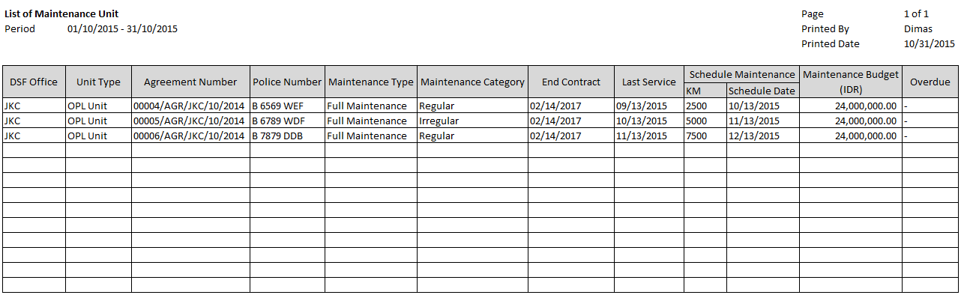

14

15

13

12

11

10

5

4

3

2

1

16

17

9

8

7

6

* 1. Entity Relationship Diagram

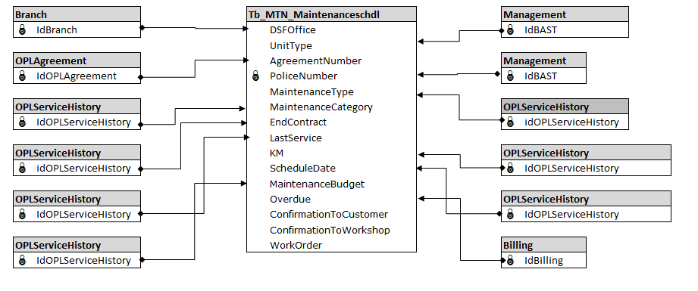

**APPENDIX**

Configuration Access for Monitor Regular Maintenance Schedule of OPL Unit:

|  |  |  |  |  |  |  |  |
| --- | --- | --- | --- | --- | --- | --- | --- |
| **User** | **Branch** | **Functions** | | | | | |
| **Display List** | **Create** | **Edit** | **View** | **Print Form** | **Print Report** |
| PIC Maintenance HO/Branch | One | V | V | V | V | V | V |
| Area |  |  |  |  |  |  |
| All |  |  |  |  |  |  |
| Marketing Officer | One | V |  |  | V | V | V |
| Area |  |  |  |  |  |  |
| All |  |  |  |  |  |  |
| Head of Branch | One | V |  |  | V | V | V |
| Area |  |  |  |  |  |  |
| All |  |  |  |  |  |  |
| Head of Department | One |  |  |  |  |  |  |
| Area |  |  |  |  |  |  |
| All | V |  |  | V | V | V |
| Regional Manager | One |  |  |  |  |  |  |
| Area | V |  |  | V | V | V |
| All |  |  |  |  |  |  |
| Advisor | One |  |  |  |  |  |  |
| Area |  |  |  |  |  |  |
| All | V |  |  | V | V | V |
| Director | One |  |  |  |  |  |  |
| Area |  |  |  |  |  |  |
| All | V |  |  | V | V | V |
| President Director | One |  |  |  |  |  |  |
| Area |  |  |  |  |  |  |
| All | V |  |  | V | V | V |
| Shareholder's Meeting | One |  |  |  |  |  |  |
| Area |  |  |  |  |  |  |
| All | V |  |  | V | V | V |
|  |  |  |  |  |  |  |  |
| **Legend:** |  |  |  |  |  |  |  |
| V = Have the access |  |  |  |  |  |  |  |